Subway Sandwich Builder User Guide

The Subway Sandwich Builder application was built to make ordering your Subway sandwich quick and easy. You can eat fresh by following the five simple steps below!

1. **How hungry are you?**  
   Use the three buttons at the top of the screen to select the size of sandwich you want to build.   
   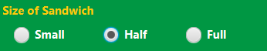
2. **Choose your bread.**  
   Use the Bread Type dropdown to select the type of bread you want our sandwich artist to use on your sandwich.   
   
3. **Select your toppings.**  
   Use the next dropdowns to choose what you want on your sandwich! You can pick from our full range of delicious meats and cheeses, and up to three fresh vegetables.   
   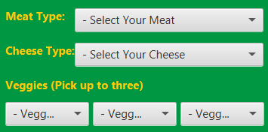
4. **Don’t forget the sauce!**  
   Use the last dropdown menu to select the sauce you want us to put on your sandwich.   
   
5. **Salt and Pepper?**   
   Last, but certainly not least, use the Yes/No buttons at the bottom of the screen to tell us if you want salt and pepper on your sandwich.   
   

As you build your sandwich, check the summary on the right-hand side of the screen to make sure your order is right! If you change your mind on a selection, you can always go back and change your ingredients. When your sandwich is perfect, click the order button and we’ll get started on your meal. Remember to eat fresh with Subway!

